# **Scar Life Insurance Project By(Moksha Dhall, Bharat Sharma, Muskan Arora)**

# 1.Home Page

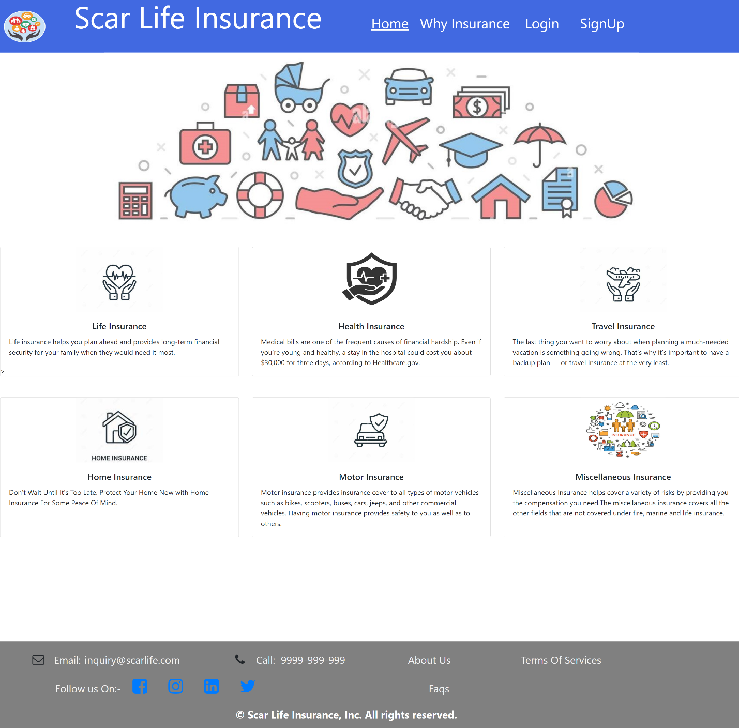

# 2.Registeration Page

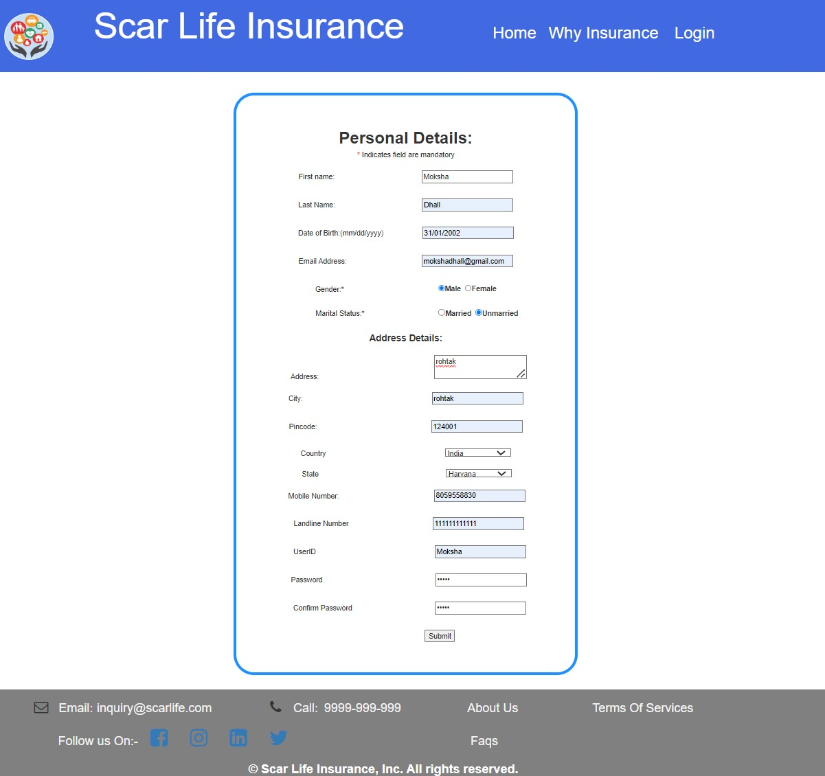

# 3.Admin Login

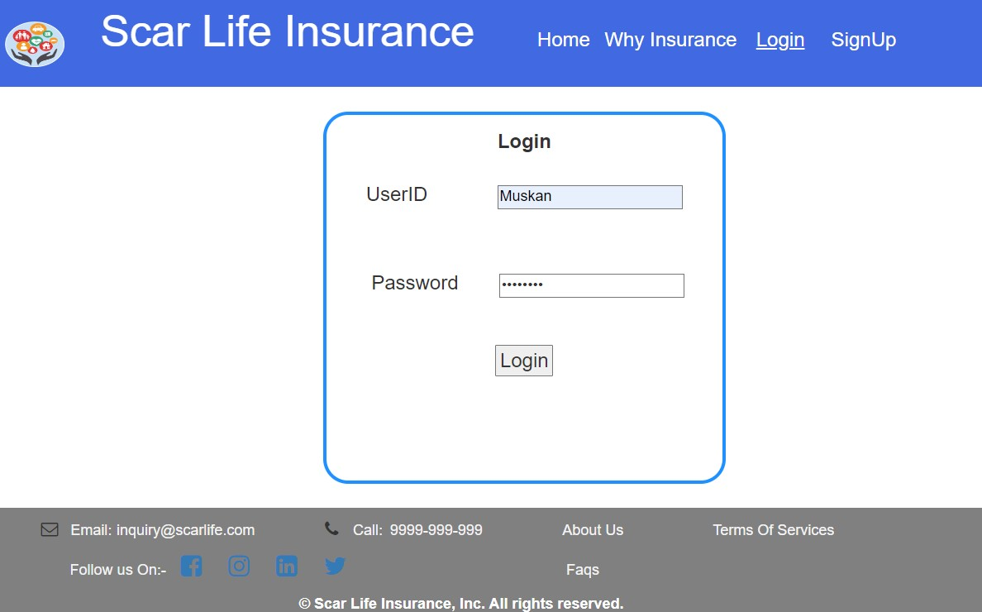

# 4. User Login

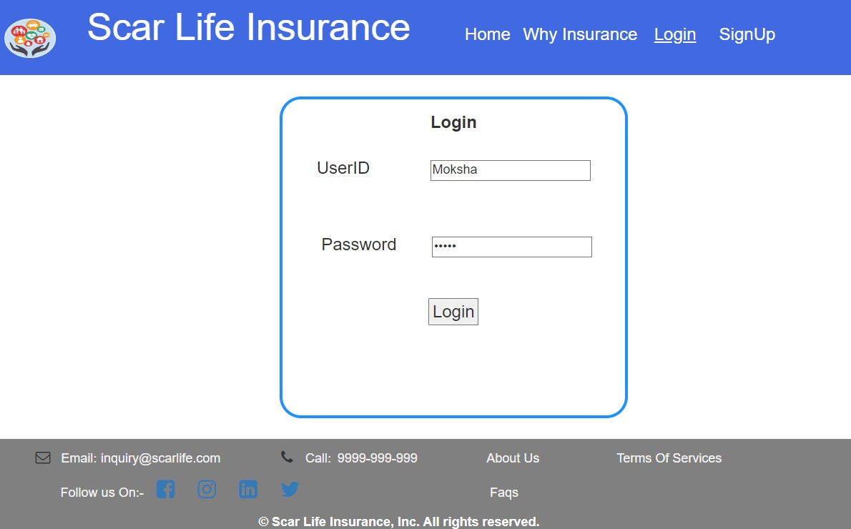

--Here is a single login page for admin and user it matches credentials and detects whether it is admin or --user and show them different pages.

# 5. Admin Panel Page

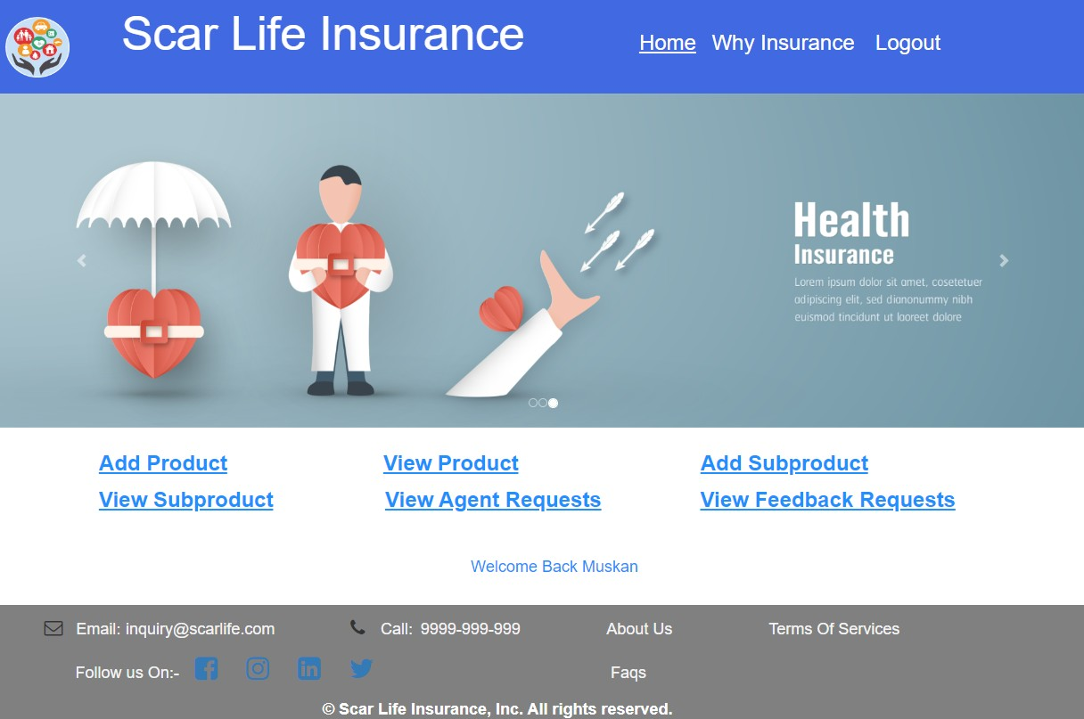

# 6.Add Products Page

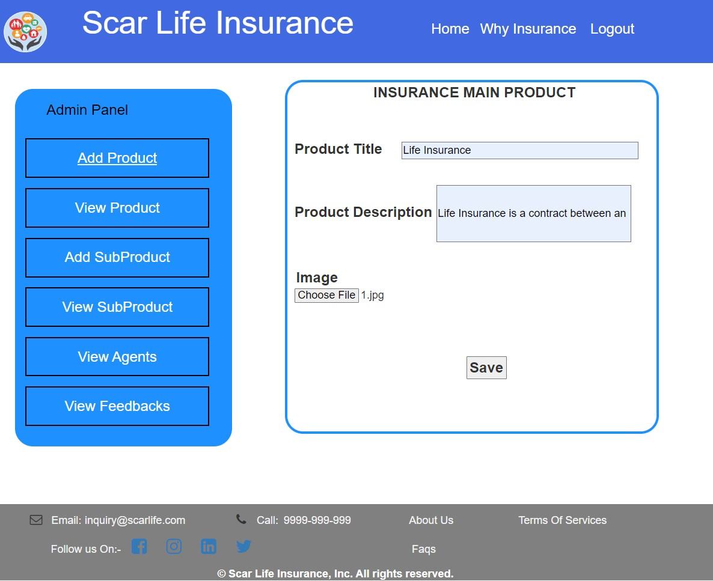

# 7. View Products Page

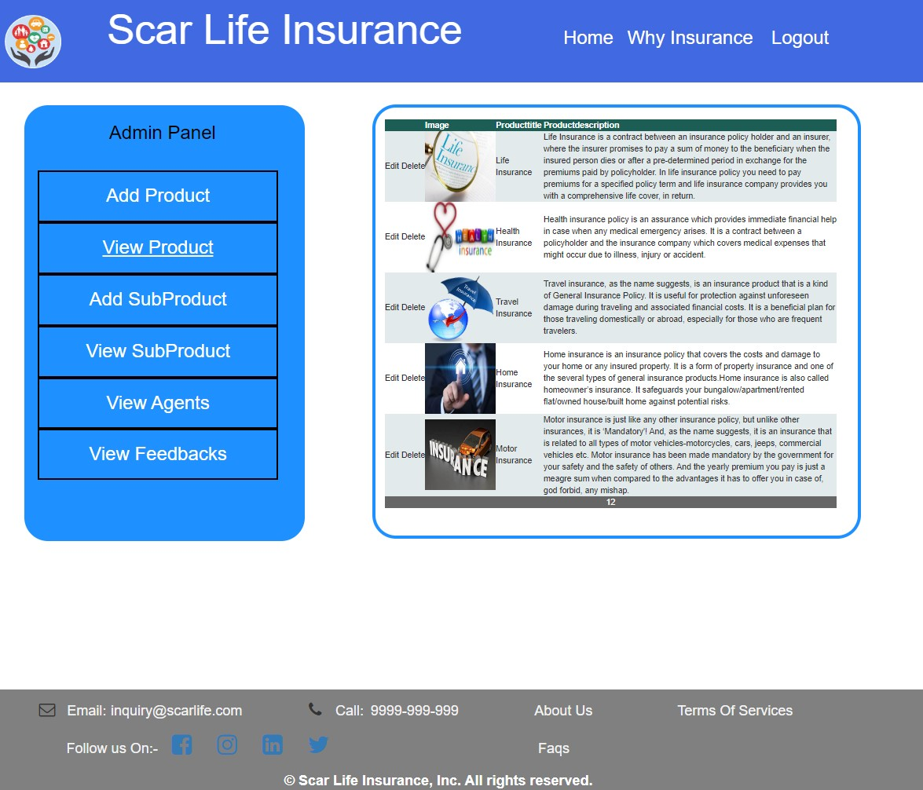

--Admin Can Edit And Delete Products.

# 8. Add Subproduct Page

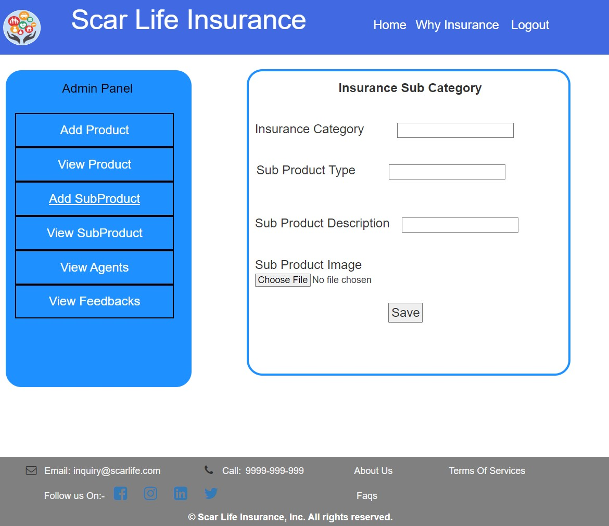

# 9. View Subproduct Page

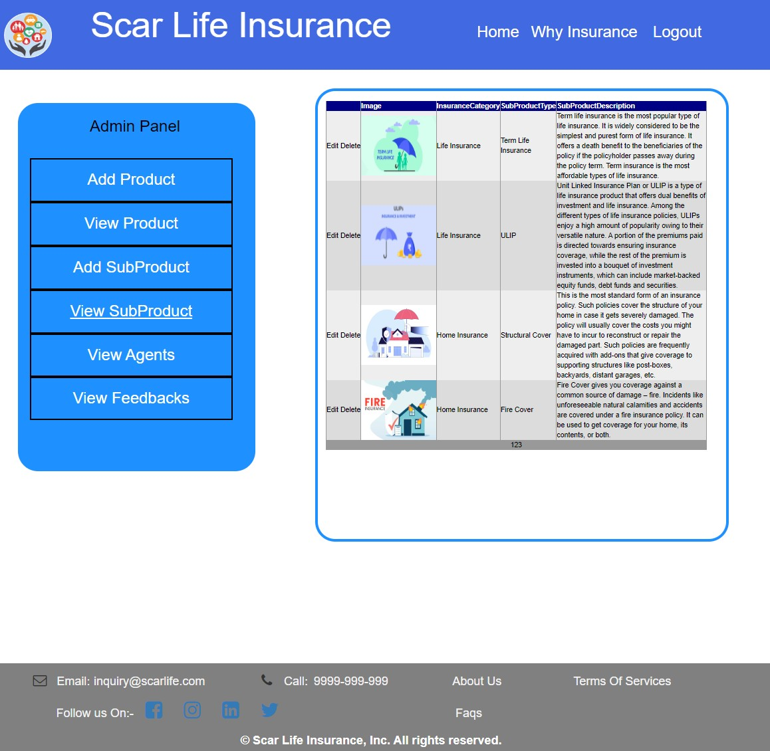

--Admin Can Edit And Delete SubProducts

# 10.View Agent Requests

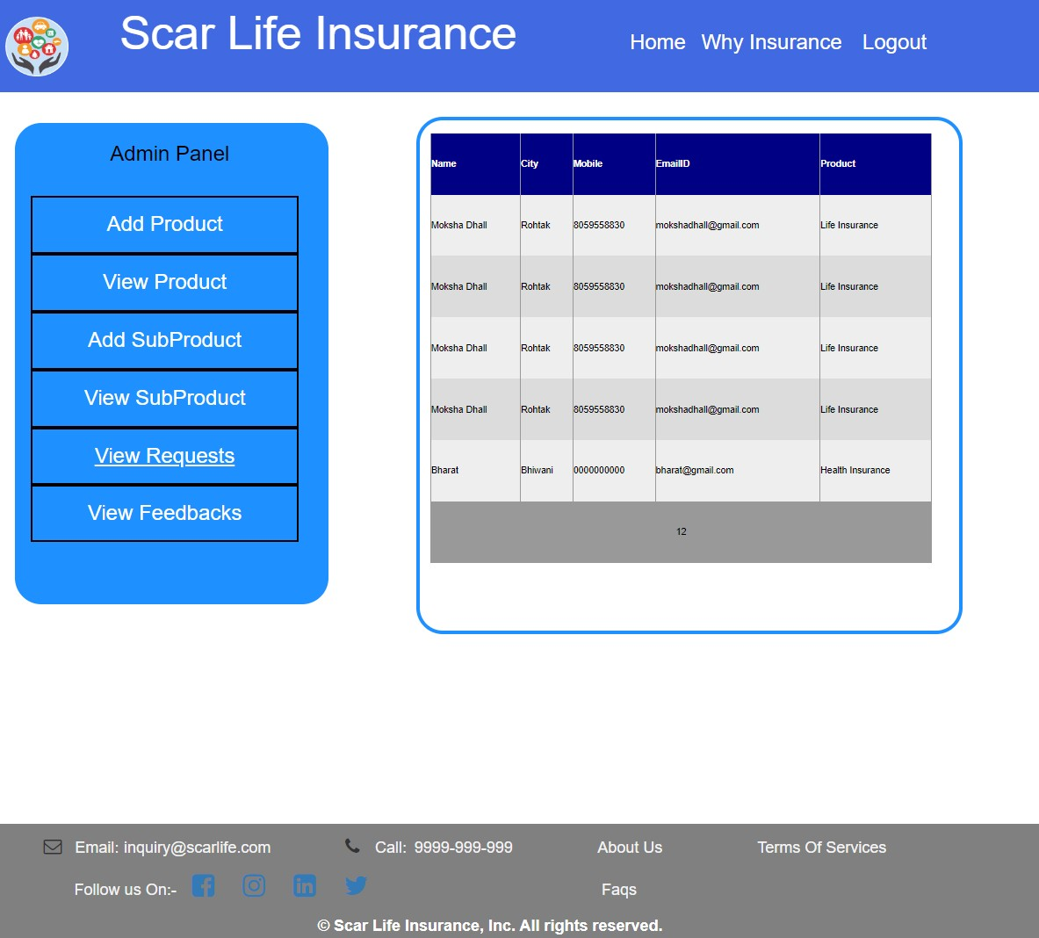

--Admin can View Agent requests.

# 11.View Feedbacks Page

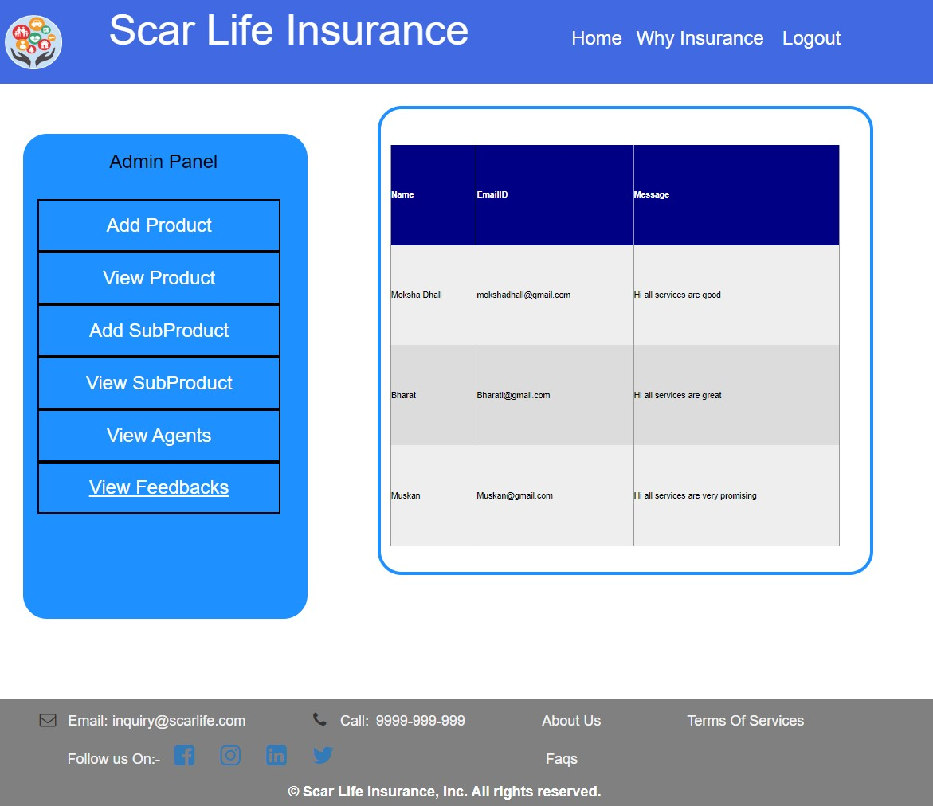

--Admin can view feedbacks.

# 12.User Panel Page



# 13.View Products

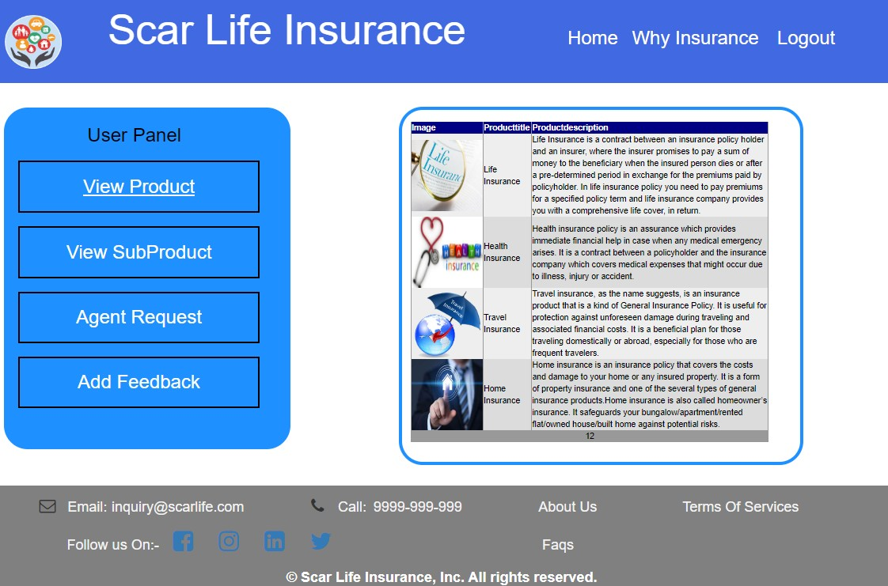

--User can see the products

# 14.View Subproducts Page

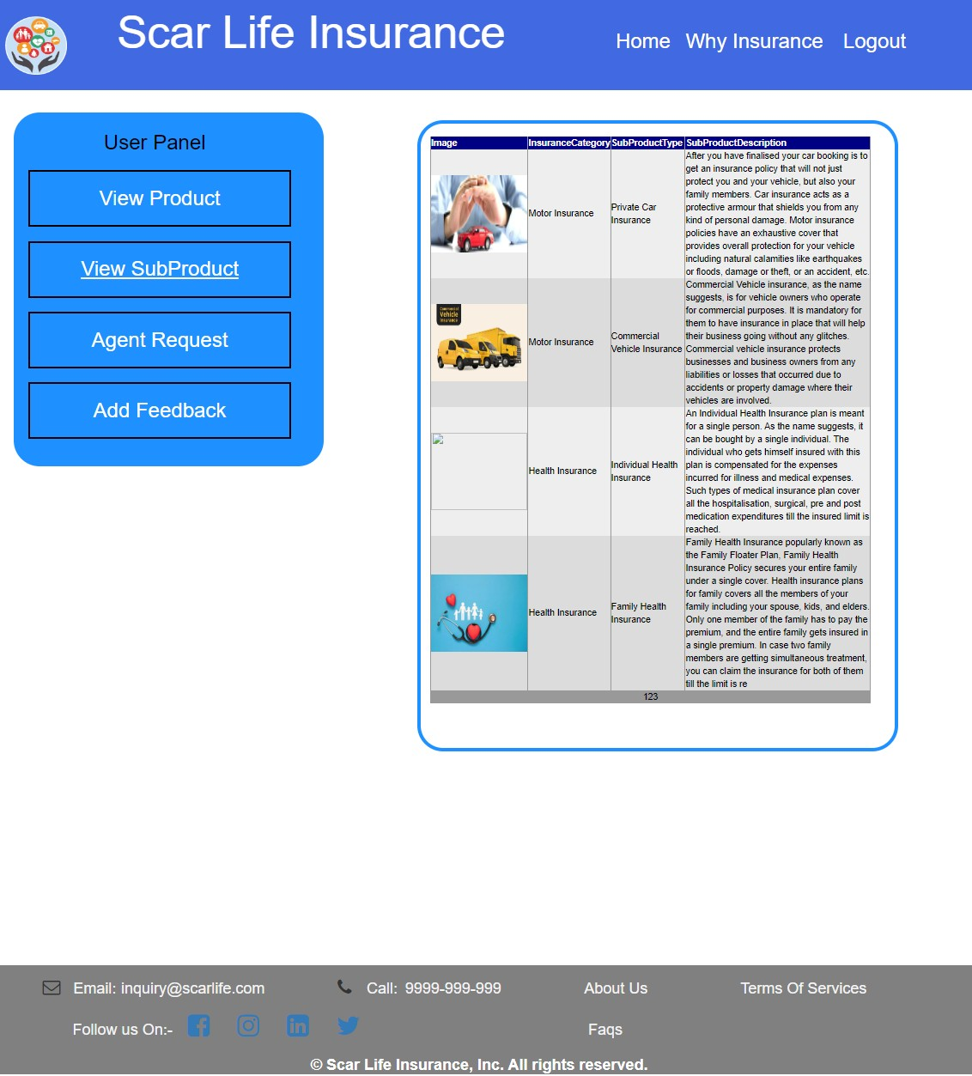

--User can see the subproducts

# 15.Request Agent Visit Page

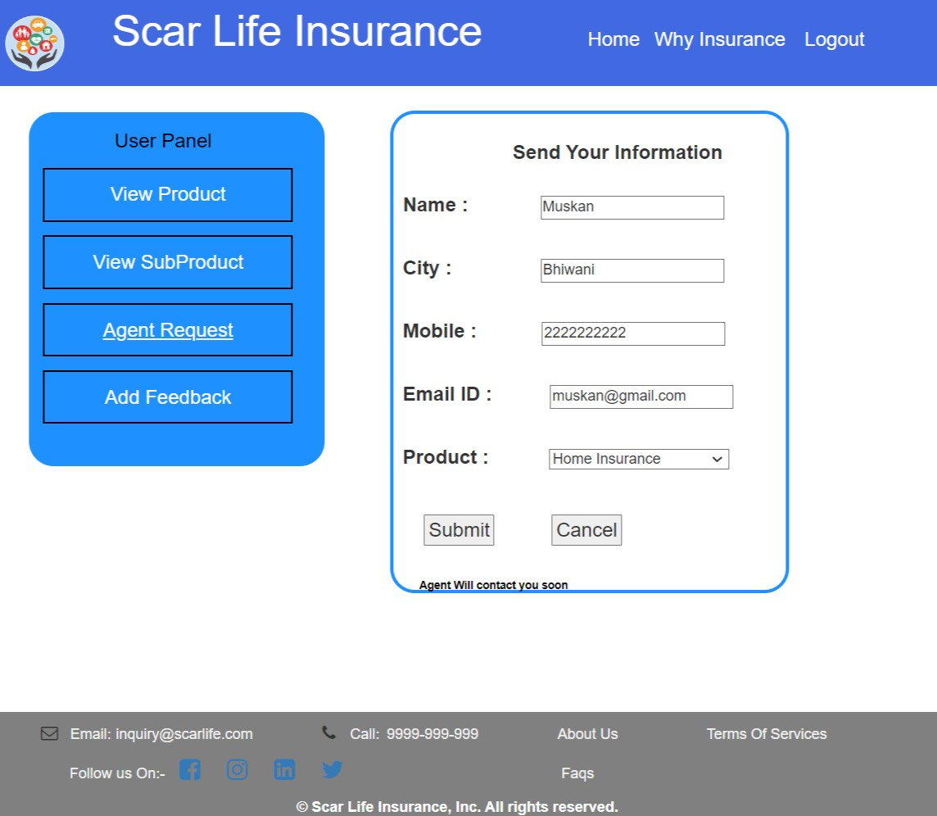

--User can book agent visit

# 16.Add Feedback Page

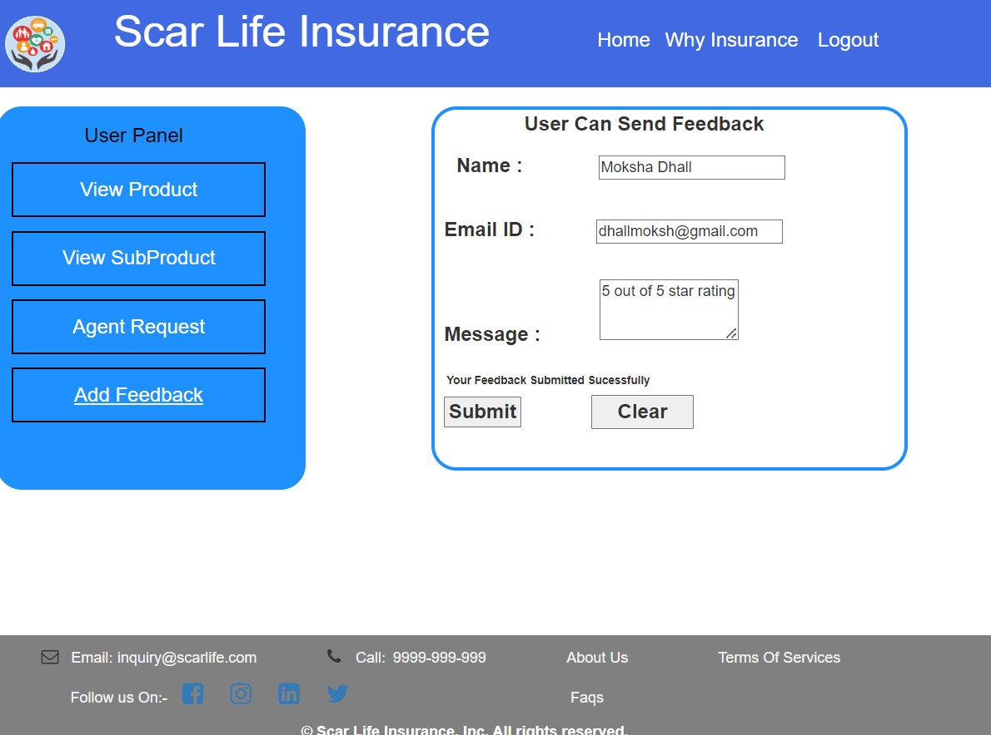

--User can add feedback.

# 17.Why Insurance Page

